1. **Download Jmeter**

<https://jmeter.apache.org/download_jmeter.cgi>

1. **Configure Java environment**

Because the version of Jmeter is 4.0, jdk 1.8 or higher version is required.

set JAVA_HOME="the path of jdk1.8"

set PATH=%JAVA_HOME%\bin;%PATH%

1. **Start Jmeter**

cd %your jmeter path%\bin

jmeter.bat

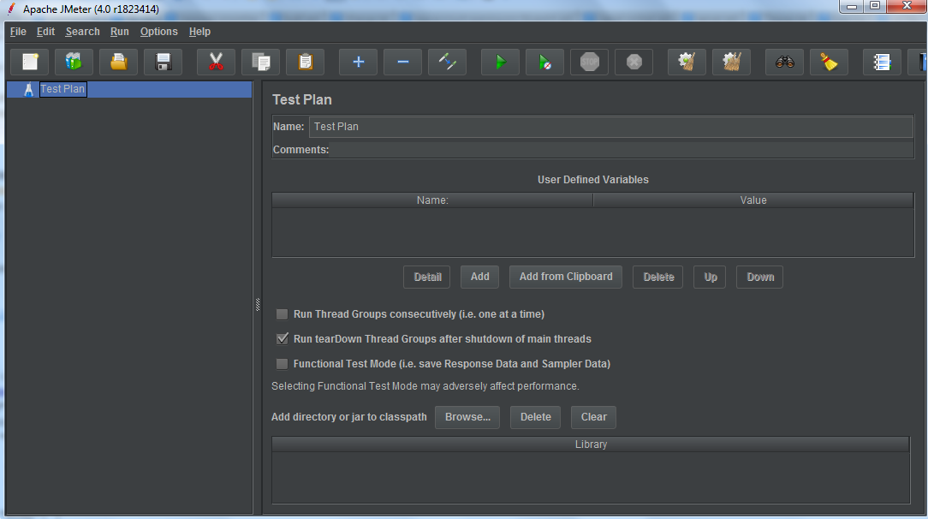

1. **Add thread group and set the number of users, the loop count**

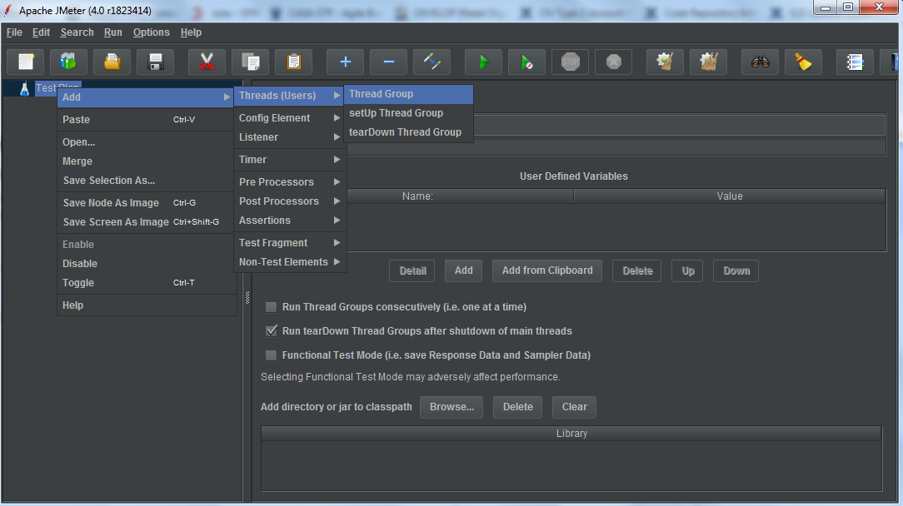

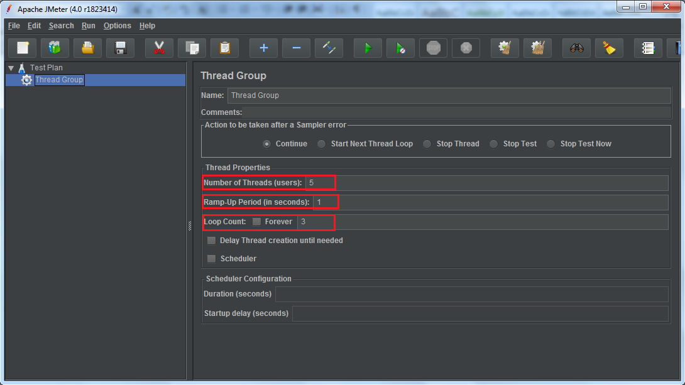

1. **Add HTTP request:**

**(I take one service for CN_CASA as an example)**

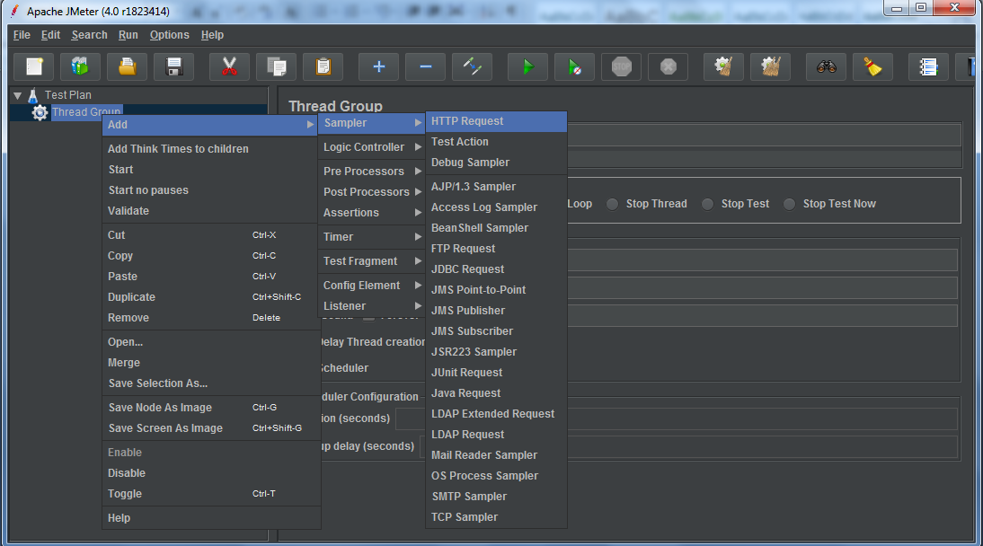

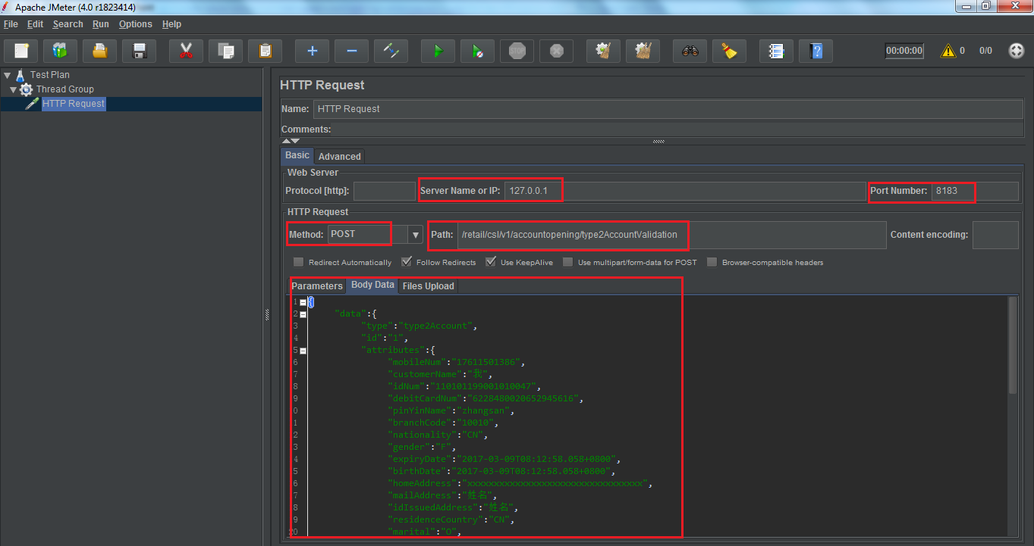

You can define some variables:

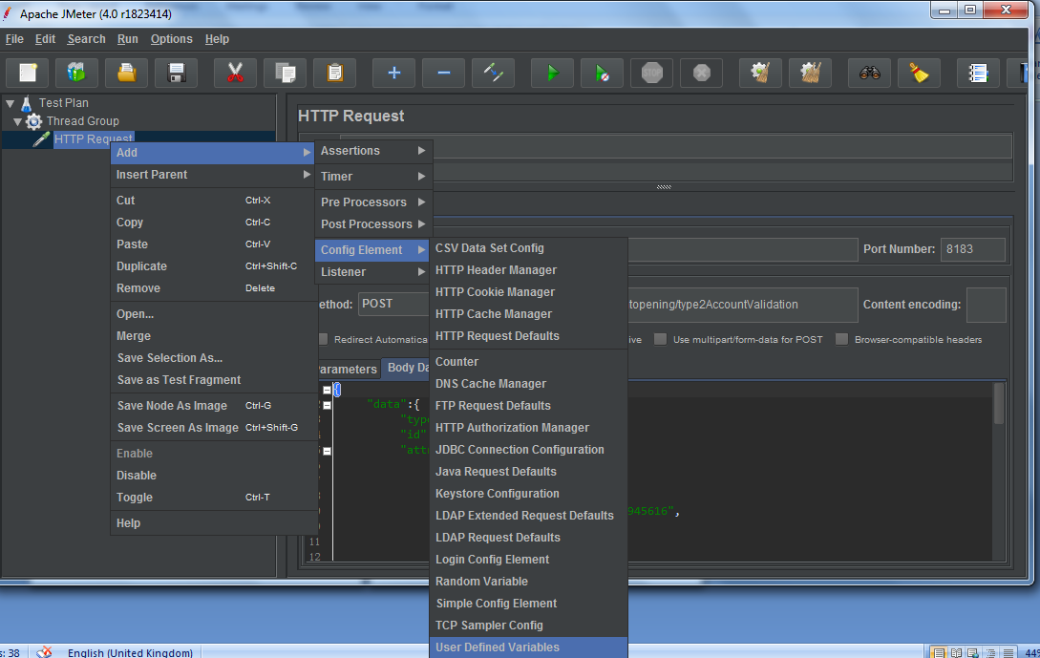

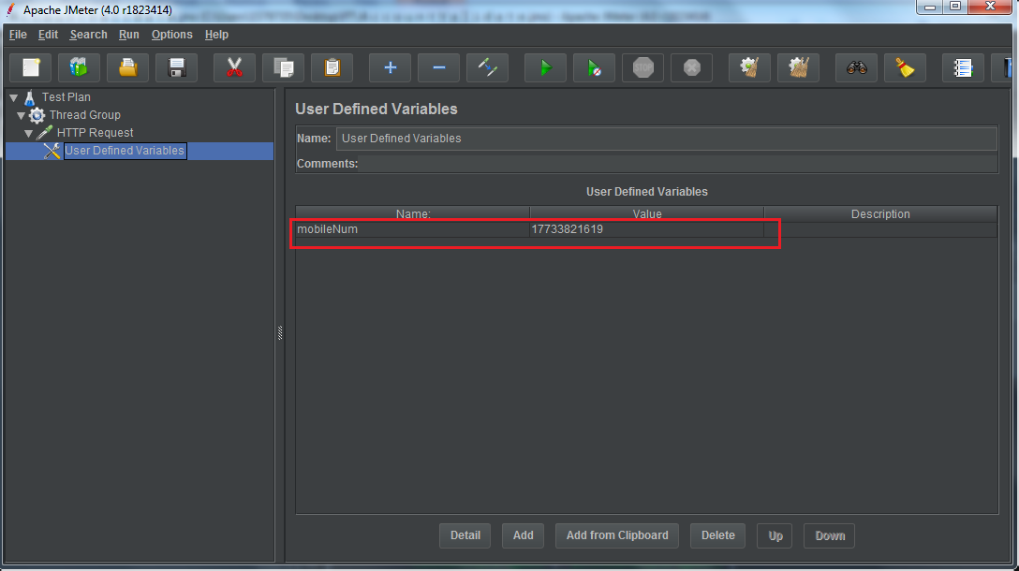

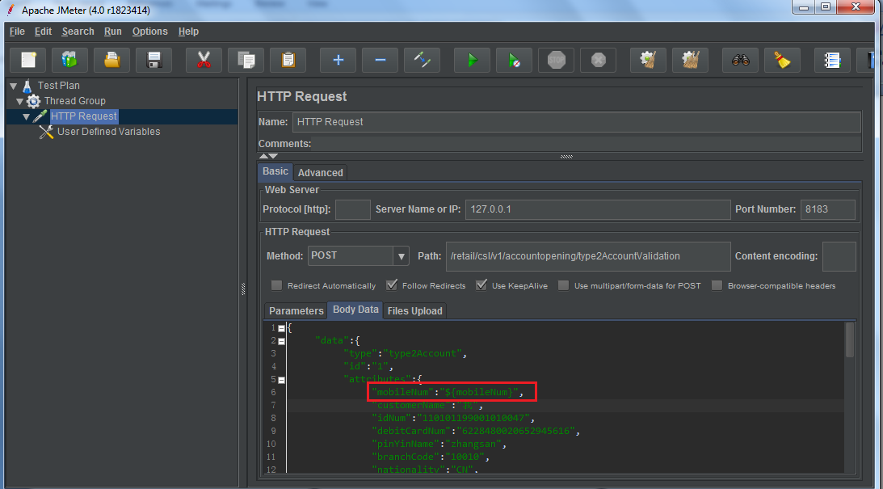

1. **Add HTTP Header Manager:**

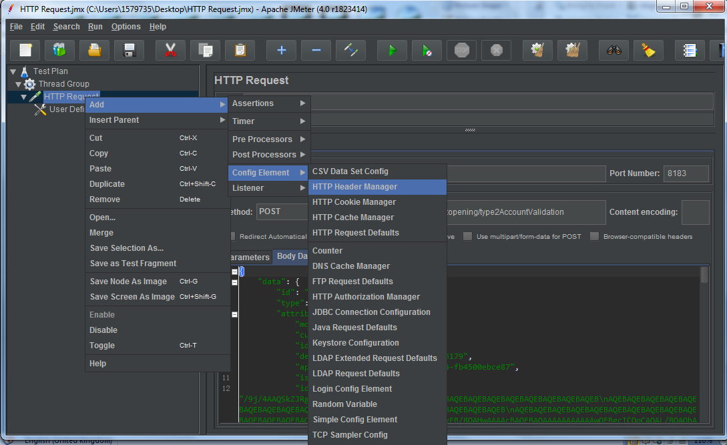

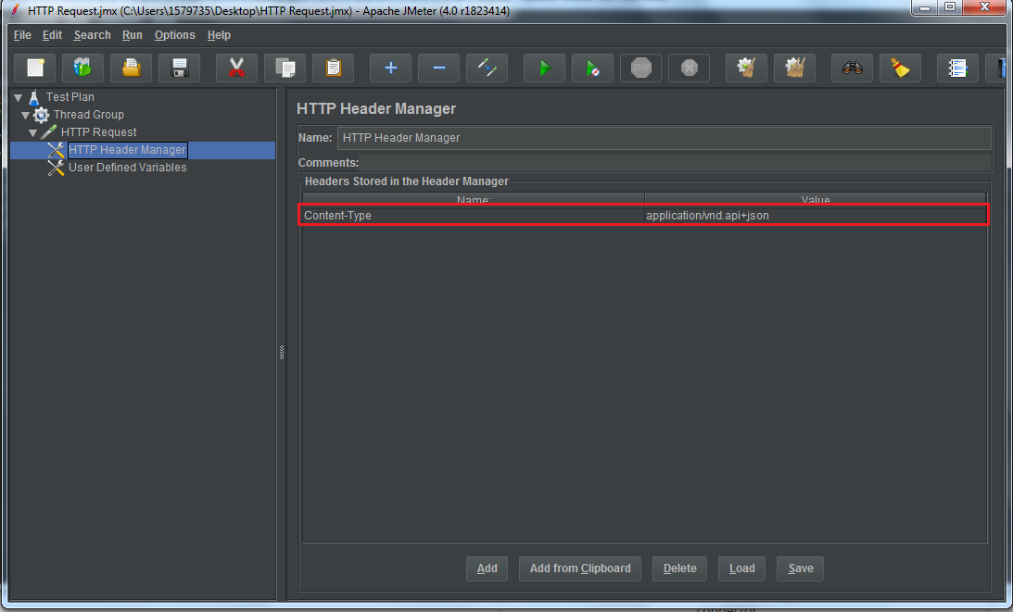

1. **Add some listeners to view the results:**

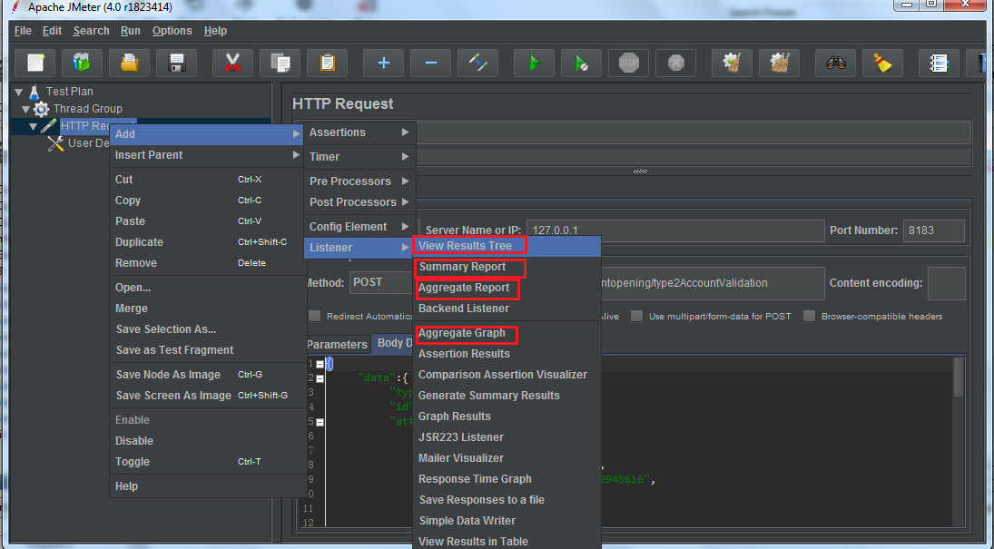

1. **Run and view the results:**

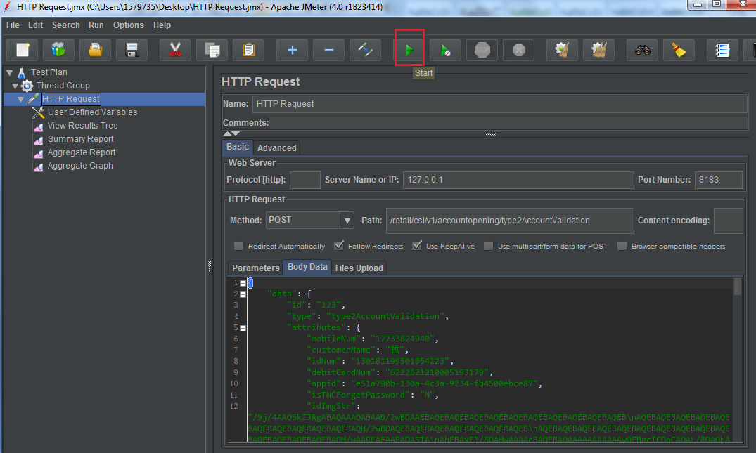

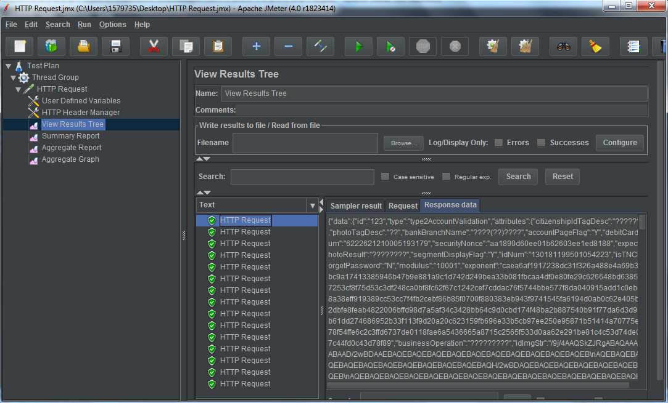

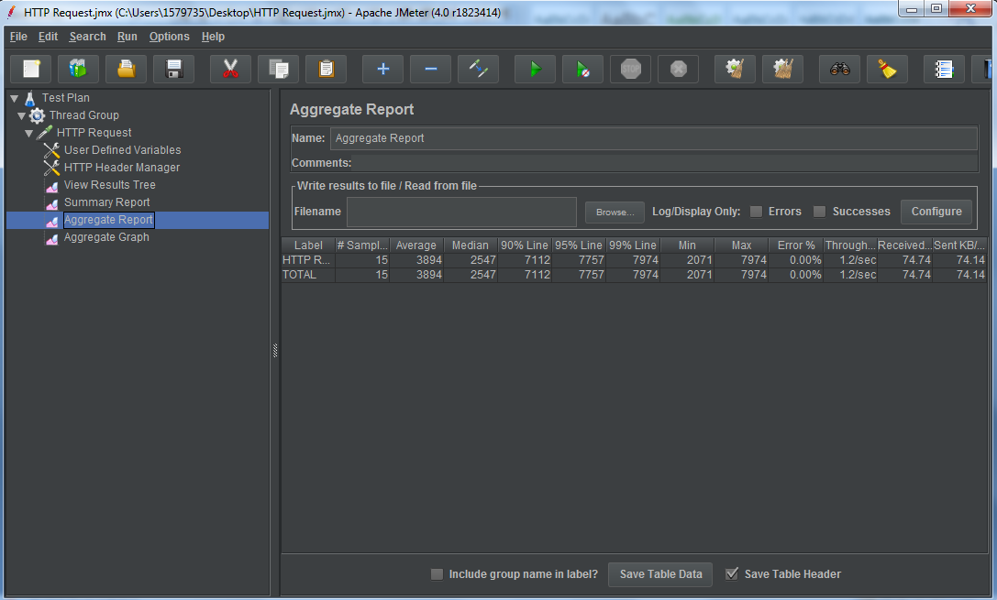

1. **A jmx script will be generated for this service and next time you want to test this service, you can just drag the script to the box.**